### Code for all parts of the lab

main.cpp:

#define _USE_MATH_DEFINES

#include <iostream>

#include <string>

#include <cmath>

#include "../Shared/dspf.hpp"

struct complex {

float Re, Im;

complex operator= (float b) {

Re = b; Im = 0;

return *this;

}

complex operator+= (complex b) {

Re += b.Re; Im += b.Im;

return *this;

}

complex operator*=(complex b) {

float x = Re, y = Im;

Re = (x * b.Re) - (y * b.Im);

Im = (x * b.Im) + (b.Re * y);

return *this;

}

};

complex operator* (complex a, complex b) {

complex c = { 0, 0 };

c.Re = (a.Re * b.Re) - (a.Im * b.Im);

c.Im = (a.Re * b.Im) + (b.Re * a.Im);

return c;

}

complex operator* (float a, complex b) {

complex c = b;

c.Re *= a; c.Im *= a;

return c;

}

complex operator+ (complex a, complex b) {

complex c = a;

return c += b;

}

complex operator- (complex a, complex b) {

complex c = a;

return c += (-1.0f * b);

}

complex polar(double mag, double angle) {

complex c = { 0, 0 };

c.Re = (float)(mag * cos(angle));

c.Im = (float)(mag * sin(angle));

return c;

}

void tune(DSPFile& in, DSPFile& out, const float& station) {

const float FS = 8.0f;

const float FC = 94.8f;

complex x[IOBUFFSIZE];

unsigned long i = 0; // On the order of 75 million (int only goes up to about 4 million)

/**

* Attempts to optimize the loop

*/

// Attempt 1 - use fopen_s instead of std::fstream (see dspf.cpp)

// Net Savings per loop: Uncertain

// Attempt 2 - Move some multiplication out of the loop

float prescale = (float)(-2 * M_PI * (station - FC) / FS); // Move some operations outside of the loop

// Net Savings per loop: 2 mult ops, 1 divide op, 1 add op

// Attempt 3 - Use periodicity of complex exponentials to precalculate values from sin/cos in polar()

float precision = 0.0001f;

std::vector<complex> periodicity;

unsigned int n = 0; // n turns out to be on the order of 16,620

periodicity.push_back(polar(1, prescale * n++));

while (true) {

periodicity.push_back(polar(1, prescale * n));

complex diff = periodicity[n++] - periodicity[0];

if (abs(diff.Re) < precision && abs(diff.Im) < precision) {

break;

}

}

// Net Savings per loop: 3 mult ops, 2 func calls (sin/cos ops, probably table-lookup based), 2 assign ops

/**

* All the above efforts don't seem to have made a significant impact on time to process 600MB file

*/

// Attempt 4 - change IOBUFFSIZE from 1024 -> 32768 (ok, we have impact now)

// Result: Processing time reduced from ~10 minutes to ~1 minute

// Attempt 5 - Revert back to std::fstream since it did not improve after attempt 1

// Result: We're back at the old speed all the sudden....wth?!

/**

* End optimization attemps

*/

int xlen = in.read_n((float*)x, 100 * 2) / 2; // Skip the first garbage 100 samples

if (xlen == 100) {

xlen = in.read_n((float*)x, IOBUFFSIZE * 2) / 2;

while (xlen > 0) {

for (int j = 0; j < xlen; ++j) {

// Performance breakdown:

// 1 mod op, 2 access ops, 4 mult ops, 2 add ops, 1 func call, 2 float alloc, 2 assign op

x[j] *= periodicity[i++ % n]; // polar(1, 2pi(ft-fc)/fs * i++)

}

out.write_d((float*)x, xlen * 2);

xlen = in.read_n((float*)x, IOBUFFSIZE * 2) / 2;

}

} else {

std::cout << "Invalid input signal file..." << std::endl;

}

}

void resample(const dsig& hsig, const int& U, const int& D, DSPFile& in, DSPFile& out) {

// Determine bounds on computed arrays

const int L = (int)hsig.size();

// Adjust the header on the output file

out.Header = in.Header;

out.Header.dim0 = (out.Header.dim0 * U) / D;

out.Header.dim1 = (out.Header.dim1 * U) / D;

out.write_h();

// It would be really nice if Dr. Gunther explained in his slides what the heck this is...

int M = L / U + ((L % U) > 0);

int N = M * U; // Padded impulse response length

int d = 0, k = 0;

complex* x = new complex[L];

const float* h = hsig.data();

complex

xbuff[IOBUFFSIZE],

ybuff[IOBUFFSIZE];

// Zero out circular buffer to clear garbage

for (int i = 0; i < M; ++i) { x[i] = 0; }

//x[i] = in.read_1();

int xlen = in.read_n((float*)xbuff, IOBUFFSIZE * 2) / 2;

int ylen = 0;

while (xlen > 0) {

for (int i = 0; i < xlen; ++i) {

k = (k + M - 1) % M;

x[k] = xbuff[i];

if (d == 0) { // Downsampling discards D - 1 values

for (int j = 0; j < U; ++j) {

complex y = { 0, 0 }; int m = 0, n = 0;

// Upsampling creates 0 every U elements of x (skipping over h because convolution is associative)

for (; n < M; ++n, m += U) {

y += h[m + j] * x[(n + k) % M];

}

ybuff[ylen++] = y;

if (ylen == IOBUFFSIZE) {

out.write_d((float*)ybuff, ylen * 2);

ylen = 0;

}

}

d = D - 1;

} else { --d; }

}

xlen = in.read_n((float*)xbuff, IOBUFFSIZE * 2) / 2;

}

if (ylen > 0) {

out.write_d((float*)ybuff, ylen * 2);

ylen = 0;

}

delete[] x;

}

int main() {

float station = 96.7f;

std::string

f_h1 = "output\\h1.bin",

f_h2 = "output\\h2.bin",

f_h3 = "output\\h3.bin",

f_h4 = "output\\h4.bin",

f_h5 = "output\\h7.bin",

f_radio = "output\\freq94_8_bw_4.bin",

f_y0 = "output\\y0.bin",

f_y1 = "output\\y1.bin",

f_y2 = "output\\y2.bin",

f_y3 = "output\\y3.bin",

f_y4 = "output\\y4.bin",

f_x = "output\\x.bin",

f_r1 = "output\\r1.bin",

f_r2 = "output\\r2.bin",

f_r3 = "output\\r3.bin";

DSPFile

fin(DSP::Mode::Read | DSP::Mode::NoHeader),

fout(DSP::Mode::Write | DSP::Mode::NoHeader),

fh1(f_h1, DSP::Mode::Read),

fh2(f_h2, DSP::Mode::Read),

fh3(f_h3, DSP::Mode::Read),

fh4(f_h4, DSP::Mode::Read),

fh5(f_h5, DSP::Mode::Read);

dsig

h1 = fh1.read_all(),

h2 = fh2.read_all(),

h3 = fh3.read_all(),

h4 = fh4.read_all(),

h5 = fh5.read_all();

fout.close();

fin.open(f_radio); fout.open(f_y0);

tune(fin, fout, station);

fout.close();

fin.open(f_y0); fout.open(f_y1);

resample(h1, 1, 2, fin, fout);

fout.close();

fin.open(f_y1); fout.open(f_y2);

resample(h2, 1, 2, fin, fout);

fout.close();

fin.open(f_y2); fout.open(f_y3);

resample(h3, 1, 2, fin, fout);

fout.close();

fin.open(f_y3); fout.open(f_y4);

resample(h4, 1, 2, fin, fout);

fout.mode(DSP::Mode::Write);

fin.open(f_x); fout.open(f_r1);

fin.Header = {1, 1, 4789058, 500000, 0 }; // Hard coded because the values are known and running out of time

resample(h5, 1, 2, fin, fout);

fin.mode(DSP::Mode::Read); fout.close();

fin.open(f_r1); fout.open(f_r2);

resample(h5, 3, 5, fin, fout);

fout.close();

fin.open(f_r2); fout.open(f_r3);

resample(h5, 1, 5, fin, fout);

system("pause");

return 0;

}

main.m

clear all;

h = [ ...

{firpm(4, [0, 1/80, 1/2 - 1/80, 1/2]*2, [1, 1, 0, 0]), 'h1', 8*10^6}; ...

{firpm(4, [0, 1/40, 1/2 - 1/40, 1/2]*2, [1, 1, 0, 0]), 'h2', 4*10^6}; ...

{firpm(6, [0, 1/20, 1/2 - 1/20, 1/2]*2, [1, 1, 0, 0]), 'h3', 2*10^6}; ...

{firpm(8, [0, 1/10, 1/2 - 1/10, 1/2]*2, [1, 1, 0, 0]), 'h4', 1*10^6}; ...

{firpm(6, [0, 3/50, 1/2 - 3/50, 1/2]*2, [1, 1, 0, 0]), 'h5', 500*10^3}; ...

{firpm(6, [0, 3/25, 1/2 - 3/25, 1/2]*2, [1, 1, 0, 0]), 'h6', 250*10^3}; ...

{firpm(6, [0, 3/15, 1/2 - 3/15, 1/2]*2, [1, 1, 0, 0]), 'h7', 150*10^3}; ...

];

h{5, 1} = lpf(2, 256); % I gave up trying to make firpm work

h{6, 1} = lpf(5, 256); % I gave up trying to make firpm work

h{7, 1} = lpf(5, 256); % I gave up trying to make firpm work

% Write header binary files

for i = 1:7

fid = fopen(sprintf('output\\%s.bin', h{i, 2}), 'wb');

fwrite(fid, [1 1 length(h{i, 1}) 1 0], 'int');

fwrite(fid, h{i, 1}, 'float');

fclose(fid);

end

% Plot h1-h4

figure(1);

for i = 1:4

subplot(4, 1, i);

[w, F, theta, r, db] = getFFT(h{i, 1}, 10, h{i, 3});

plot(w, db);

ylabel('Magnitude (dB)');

xlabel('Frequency (Hz)');

title(sprintf('LPF %i', i));

end

sig = [ ... % file, f, f_c

{'freq94_8_bw_4', 0, 0, 'Original Signal', 8*10^6, 0, 0, 0, 0, 0}; ...

{'y0', 0, 0, 'After Fruency Shift', 8*10^6, 0, 0, 0, 0, 0}; ...

{'y1', 0, 0, 'After LPF 1', 4*10^6, 0, 0, 0, 0, 0}; ...

{'y2', 0, 0, 'After LPF 2', 2*10^6, 0, 0, 0, 0, 0}; ...

{'y3', 0, 0, 'After LPF 3', 1*10^6, 0, 0, 0, 0, 0}; ...

{'y4', 0, 0, 'After LPF 4', 500*10^3, 0, 0, 0, 0, 0}; ...

];

% Read binary files for each stage

for file = 1:6

fid = fopen(sprintf('output\\%s.bin', sig{file, 1}), 'rb');

sig{file, 2} = fread(fid, inf, 'float');

fclose(fid);

sig{file, 3} = reshape(sig{file, 2}, [2, size(sig{file, 2}, 1)/2]).';

sig{file, 3} = complex(sig{file, 3}(:,1), sig{file, 3}(:,2));

[w, F, theta, r, db] = getFFT(sig{file, 3}, 21, sig{file, 5});

sig{file, 6} = w;

sig{file, 7} = F;

sig{file, 8} = theta;

sig{file, 9} = r;

sig{file, 10} = db;

end

%Plot the FFT

figure(2);

for file = 1:6

subplot(6, 1, file);

plot(sig{file, 6}, sig{file, 10});

ylabel('Magnitude (dB)');

xlabel('Frequency (Hz)');

title(sig{file, 4});

end

% Recover x[n]

d = firpm(66, [0, 0.2, 0.25, 0.5]/0.5, [0, 1, 0, 0], 'differentiator');

f = sig{6, 3};

u1 = real(f);

v1 = imag(f);

v2 = conv(v1, d);

u2 = conv(u1, d);

delay = zeros(1, 67);

delay(34) = 1;

u1 = conv(u1, delay);

v1 = conv(v1, delay);

f = ((u1 .* v2) - (v1 .* u2)) ./ sqrt(abs(u1).^2 + abs(v1).^2);

f(isnan(f)) = 0;

[w, F, theta, r, db] = getFFT(f, 21, 500*10^3);

% Plot the spectrum of x[n]

figure(3);

plot(w, db);

ylabel('Magnitude (dB)');

xlabel('Frequency (Hz)');

title('Recovered Radio Signal');

% Plot h5-h7

figure(4);

for i = 5:7

[w, F, theta, r, db] = getFFT(h{i, 1}, 10, h{i, 3});

subplot(3, 1, i - 4);

plot(w, db);

ylabel('Magnitude (dB)');

xlabel('Frequency (Hz)');

title(sprintf('LPF %i', i));

end

Write binary file for recovered x[n]

fid = fopen('output\\x.bin', 'wb');

fwrite(fid, f, 'float');

fclose(fid);

% Read binary files for each stage

audio = [ ... % file, x, fs

{'r1.bin', 0, 0}; ...

{'r2.bin', 0, 0}; ...

{'r3.bin', 0, 0}; ...

];

figure(5);

for file = 1:3

[audio{file, 2}, audio{file, 3}] = bin2audio(audio{file, 1});

[w, F, theta, r, db] = getFFT(audio{file, 2}, 21, audio{file, 3});

subplot(3, 1, file);

plot(w, db);

ylabel('Magnitude (dB)');

xlabel('Frequency (Hz)');

title(sprintf('After LPF %i', file));

end

% Play the bad news

soundsc(audio{3,2}, audio{3,3});

lpf.m

function [h] = lpf(D, L)

fpass = 0.97/(2*D);

fstop = 1.03/(2*D);

f1 = (fstop + fpass)/2;

f2 = (fstop - fpass)/2;

n = (-L:L).';

h = (1/D)*sinc(2*f1*n).*sinc(2*f2*n);

end

getFFT.m

function [freq, F, phase, mag, db] = getFFT(f, size, scale)

if nargin == 2

scale = 1;

end

NFFT = 2 ^ size;

freq = (((0:NFFT-1)/NFFT) - 0.5) * scale;

F = fftshift(fft(f, NFFT));

phase = angle(F);

mag = abs(F);

db = 20*log10(mag);

end

### Output for Part 1

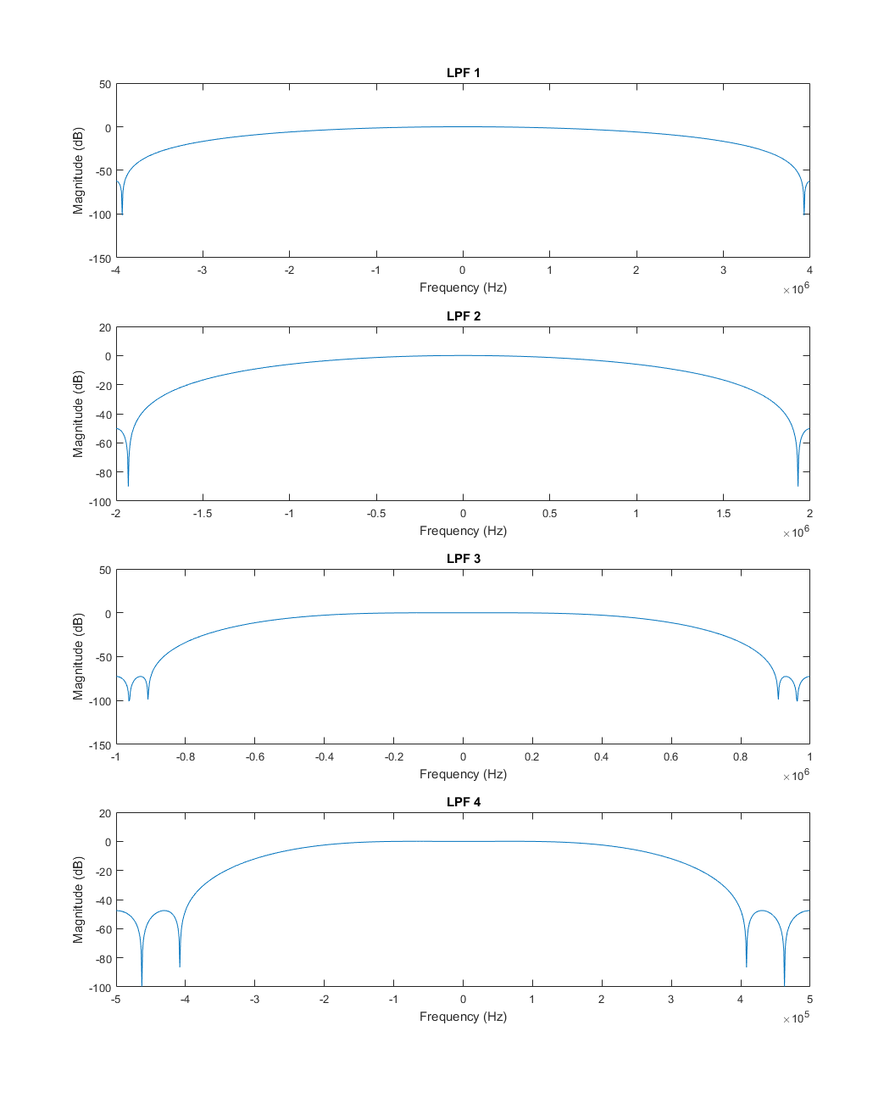

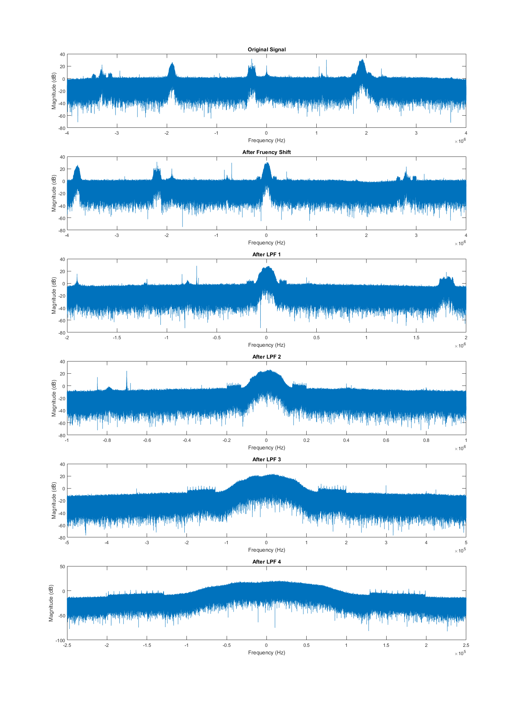

### Output for Part 2

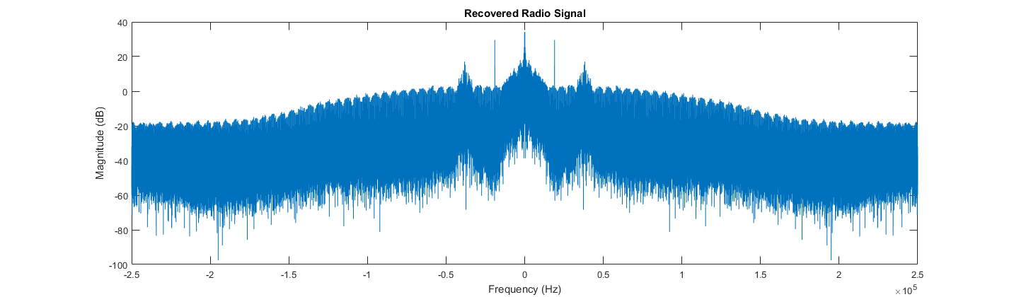

### Output for Part 3

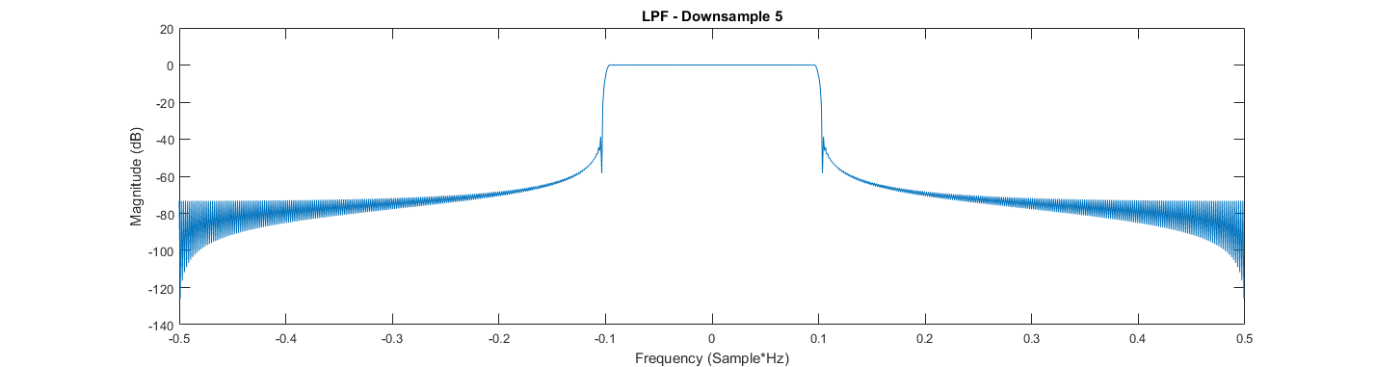

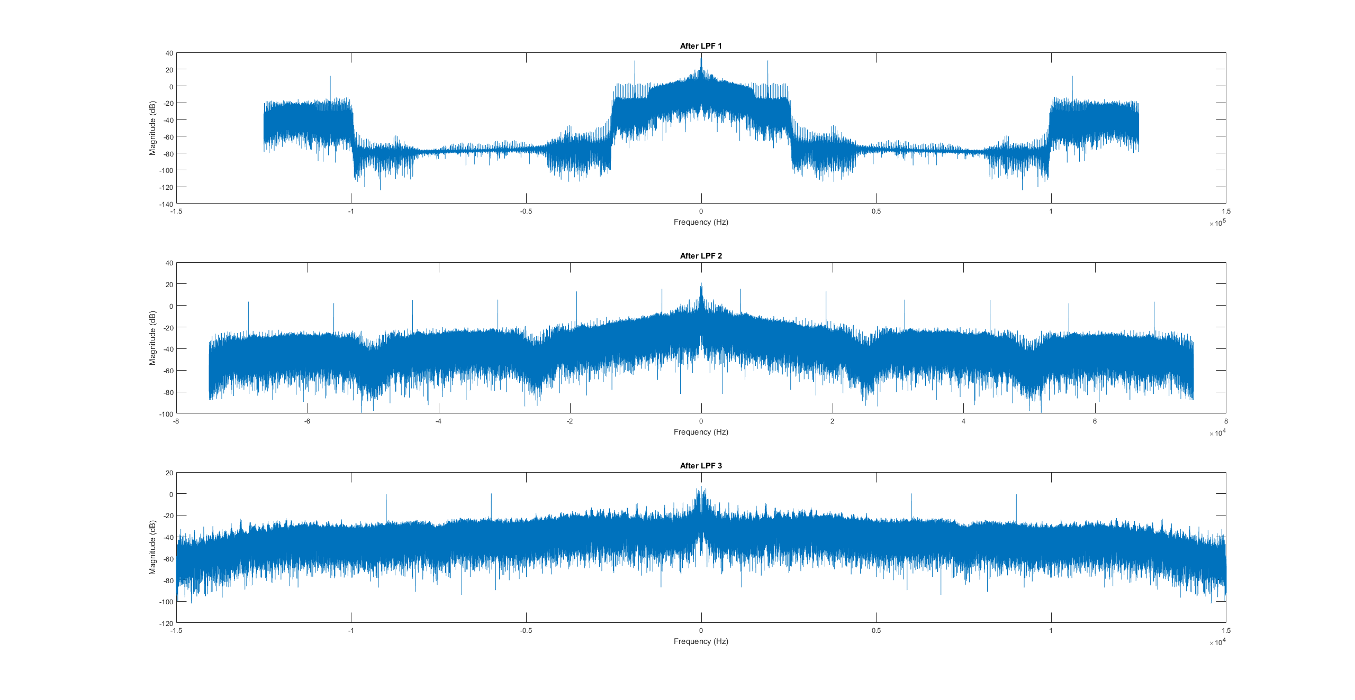

As for the filter used in part 3: I had a hard time getting firpm to create a filter according to the needs of the lab, so I borrowed from code from lab 4 to create a filter for downsampling by 5 (see lpf.m). For the first downsample by 2 since the actual content of interest is significantly lower frequency than half the spectrum there is no harm in filtering out additional frequency. So, for convenience, I used the same filter for all three steps.